Date:
Position Applying For:
Wage/Salary Desired:
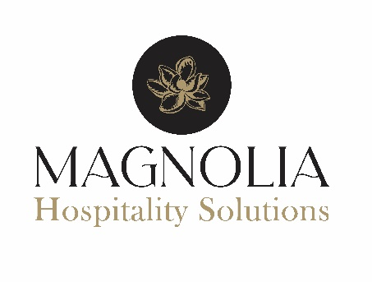
Application for Employment

Name:
Last |  |  | First |  | Middle Initial |  |  | Social Security Number | r:
Current Address:
Street Address: |  |  |  | City: | State: |  |  |  | Zip Code:
Phone Number: |  | Mobile Phone Number |  |  |  |  | E-Mail Address:
Emergency Contact:
Name: Phone Number: Relationship:

Answer All Questions:
Are you a citizen of the U.S. or do you  have a legal right to work in the U.S.? |  |  | Yes☐ | No☐ | Any offer of employment is conditional upon you  completing Form I-9 and providing documents establishing your identity and work authorization.
Are you 18 years of age or older? |  |  | Yes☐ | No☐ | If under 18 years of age, applicant will be required to submit a birth certificate or work certificate as required by State or Federal law.
Are you awaiting trial or have you ever pleaded "guilty", "No-contest" or been convicted of a crime? |  |  | Yes☐ | No☐ | If "Yes", When and Where?
Have you ever worked for Magnolia Hospitality Solutions before? |  |  | Yes☐ | No☐ | If "Yes", When and Where?
Do you have any relatives or friends that work for Magnolia Hospitality Solutions. |  |  | Yes☐ | No☐ | If “Yes”, Who and Where?
If “Yes”, please provide additional details:
Type of employment desired: | Full-Time ☐ |  |  | Part-Time ☐ |  | Date Available to Start:
How many hours per week  would you like to work? |  |  |  | Are you able to reliably make it to work?
How were you referred to us?
Availability
Hours Available to Work: | Sun | Mon | Tue | Wed | Thurs | Fri | Sat
From:
To:

Education
Are you presently enrolled in school? |  | Yes ☐ |  | No | ☐
If yes, please provide name and address of the school you are attending:

School Name and Address: |  |  |  |  | Type Of Degree or Program: |  | Expected Completion Date:
Did you successfully complete high school and receive a diploma? | Yes ☐ | No  ☐ | If you did not complete high school, do you have a high school equivalency diploma (GED)? |  |  |  | Yes ☐ | No  ☐
Name and address of last school attended:
School Name and Address: | Dates Attended:  From: To: |  | Did You Graduate?  Yes No |  | Date Of Degree: | Major:
 |  |  | ☐ | ☐
List any other education, degrees, special skills, qualifications or certifications:

Employment History
Company Name and Address: |  |  | Job Title:
Company Phone Number: | Supervisor Name: | Dates Of Employment: |  | From: | To:
Last Pay Rate: | Reason For Leaving (If Applicable): | May We Contact This Employer? |  | Yes:  ☐ | No:  ☐
Company Name and Address: |  |  | Job Title:
Company Phone Number: | Supervisor Name: | Dates Of Employment: |  | From: | To:
Last Pay Rate: | Reason For Leaving (If Applicable): | May We Contact This Employer? |  | Yes:  ☐ | No:  ☐

References
Name: | Address: | Phone: | Relationship To You:

I understand that employment is contingent upon providing authentic proof of identity and employment eligibility in the United States, and for some positions passing a drug and alcohol test. I agree to be possibly submitted to drug testing as part of the hiring process with the employer, and understand that I will receive separate notice and release before testing. I agree to immediately notify Magnolia Hospitality Solutions if I should be convicted of a felony, or any crime involving dishonesty, breach of confidentiality, controlled substances, sexual misconduct, abuse or violence while my job application is pending, or if hired, during employment. I acknowledge that employment with this employer would be at-will and that this application for employment does not create an employment contract or promise of employment

I have been given the opportunity to read this employment application thoroughly and ask questions. My signature on this form attests that all information I provided to the employer is true and complete. I understand that any false or misleading information, or significant omission, may disqualify me from consideration for employment; or if hired, may lead to my dismissal if discovered at a later date. I understand that consideration for employment may depend upon results from my references and potential background check. I grant Magnolia Hospitality Solutions or its authorized agent, permission to obtain personal investigative reports on me, including, but not limited to statements made in this application or resume, character information, general reputation, education, licensing or certifications. I authorize and release from legal liability, any individual, school, institution(s), or employer providing information or opinion with respect to potential employment with this employer
Signature of Applicant: | Date:

